

**MINI PROJECT REPORT**

**ON**

**WEBSITE:**

**BE A GUITARIST**

Submitted for the partial fulfillment of award of

**BACHELOR OF TECHNOLOGY**

**In**

**Computer Science & Engineering By**

Shariq Khan (2002220100148)

I.T.S ENGINEERING COLLEGE

**GREATER NOIDA**

**2022-2023**

**Table of Contents**

ABSTRACT 2

ACKNOWLEDGEMENT 3

1. INTRODUCTION TO PROJECT 4
   1. HTML

2.2 CSS

1. **SYSTEM REQUIREMENTS 6**

## ABOUT GUITARS 7

## ADVANTAGES 8

## PROJECT CODE 9

## ABOUT CASCADIN SHEETS 13

## RESULT 14

## CONCLUSION 16

## REFERENCE 17

# Abstract

The main objective for developing this module is to provide all the required necessities to a beginner trying to learn Guitars. It contains all the links and videos for a beginner. We have developed all types of chords and made a separate library for that . The capstone project entitled “Be A Guitarist” is an online platform designed and developed in HTML & CSS. It is aimed as an alternative in the field of learning music.

# Acknowledgement

In successfully completing this project. I would like to thank all those who are related to this project. Primarily, I would thank my Ma’am Akansha Sharma, under whose guidance I learned a lot about this project her suggestions and directions have helped in the completion of this project. Finally, I would like to thank my parents and friends who have helped me with their valuable suggestions and guidance and have been very helpful in various stages of project completion.

# CHAPTER 1 INTRODUCTION TO PROJECT

This is a website for beginners who wish to learn guitar be a fluent guitarist. Being a guitarist, I know the hardships and difficulties faced by the beginner guitarists in India when thy just start off with their love for music.

This website is for anyone who wish to learn guitar, it contains all the necessary information needed by a beginner in this field, from buying guides to buying links and video lessons to chord library everything is well curated.

## HTML

The Hyper Text Markup Language or HTML is the standard markup language for documents designed to be displayed in a web browser. It can be assisted by technologies such as Cascading Style Sheets (CSS) and scripting languages such as JavaScript.

Web browsers receive HTML documents from a web server or from local storage and render the documents into multimedia web pages. HTML describes the structure of a web page semantically and originally included cues for the appearance of the document.

## CSS

Cascading Style Sheets (CSS) is a style sheet language used for describing the presentation of a document written in a markup language such as HTML or XML (including XML dialects such as SVG, MathML or XHTML).CSS is a cornerstone technology of the World Wide Web, alongside HTML and JavaScript.

CSS is designed to enable the separation of content and presentation, including layout, colors, and fonts. This separation can improve content accessibility; provide more flexibility and control in the specification of presentation characteristics; enable multiple web pages to share formatting by specifying the relevant CSS in a separate .CSS file, which reduces complexity and repetition in the structural content; and enable the .CSS file to be cached to improve the page load speed between the pages that share the file and its formatting. Separation of formatting and content also makes it feasible to present the same markup page in different styles for different rendering methods, such as on-screen, in print, by voice (via speech-based browser or screen reader), and on Braille-based tactile devices. CSS also has rules for alternate formatting if the content is accessed on a mobile device.

The **:hover** [CSS](https://developer.mozilla.org/en-US/docs/Web/CSS) [pseudo-class](https://developer.mozilla.org/en-US/docs/Web/CSS/Pseudo-classes) matches when the user interacts with an element with a pointing device, but does not necessarily activate it. It is generally triggered when the user hovers over an element with the cursor (mouse pointer).

CSS is designed to enable the separation of content and presentation, including layout, colors, and fonts. This separation can improve content accessibility; provide more flexibility and control in the specification of presentation characteristics; enable multiple web pages to share formatting by specifying the relevant CSS in a separate .CSS file, which reduces complexity and repetition in the structural content; and enable the .CSS file to be cached to improve the page load speed between the pages that share the file and its formatting. Separation of formatting and content also makes it feasible to present the same markup page in different styles for different rendering methods, such as on-screen, in print, by voice (via speech-based browser or screen reader), and on Braille-based tactile devices. CSS also has rules for alternate formatting if the content is accessed on a mobile device.

html and css are two of the most important web technologies. They are used to create the structure and design of a website.Headless browsers are an integral part of web development. They allow developers to test and debug a website without having to actually browse the site in a browser. This process can be used for things such as testing layouts, checking cross-browser compatibility, checking page load speeds and more.The html code is what defines the content and layout of a website, while css is what defines how that content will be styled. Together, they allow designers to create stunning websites with ease.

**Hardware:**

# CHAPTER 2 SYSTEM REQUIREMENTS

* + - Processor – i3 or above.
    - RAM – 4 Gb or above.
    - Drive space – 4Gb or above.

## Software:

* + - Operating System: Windows 7 or above
    - Internet Speed: Stable internet connection required.

# CHAPTER 3 ABOUT GUITARS

## Needs of this website

The main objective of this website is to help beginners in the field of music and provide them the required links and videos to help n their journey of being a guitarist. Also the website can be used as an affiliate marketing platform by directing users to amazon to buy their instruments.

## Chord Library

The chord library is one of the most important tools for every guitarist. It provides a wide range of chords and diagrams in different positions. A chord library is a collection of chords that can be used as the foundation for songwriting. This capability is one of the most important tools that every musician should have in their repertoire.

## Guitar Buying Guide

Shopping for your first instrument should be the initial step in a lifelong journey of learning and inspiration. It can also be confusing because all musical instruments come in so many different makes and models.

If you’re buying your first guitar, you’ll face choices like what size guitar to buy, deciding between an acoustic or electric, or whether to invest in a new or used instrument. While there are many variables that might affect your decision, the most important thing is to find a guitar that sounds good, looks good, and feels good to play - to you.

## Guitar Lessons

Learning the guitar can be a great way to start your musical journey. There are many different aspects of learning the guitar that beginners should take into consideration including getting used to the instrument and learning how to read music. Guitar lessons are an important part of this process, as they provide invaluable feedback from an experienced teacher.

## Types of Guitars

The word 'guitar' means something different for everyone. It could be the roar of a Les Paul electric through a Marshall guitar amp, the delicate fingerpicking of a seasoned classical player, or the resonant strum of a steel-string acoustic around a campfire.

# Chapter 4 ADVANTAGES

## Interest Generator

With a learning website present on the internet, the people will get interested mor in plying guitars. Moreover, a normal user will also get interested if they visit the website.

## Helps with motivation

A fantastic learning website will inspire guitarists. They will study and be inspired by a variety of videos, and chord libraries will make their journey easier and give them more confidence.

## Wide range

website offers a variety of learning resources, including libraries, buying tips, videos, buying links, and everything a novice could need

# Chapter 5 Project source code

<!DOCTYPE html>

<html lang="en">

<head>

    <meta charset="UTF-8">

    <meta http-equiv="X-UA-Compatible" content="IE=edge">

    <meta name="viewport" content="width=device-width, initial-scale=1.0">

    <link rel="stylesheet" href="style.css">

    <link rel="shortcut icon" href="logo.ico">

    <title>Be a Guitarist!</title>

</head>

<body>

    <h1 class="head">

        <img src="guitar.png" alt="logo">

        <center><h1 style="color: bisque;">BE A GUITARIST</h1></center>

    </h1>

    <nav>

        <div class="logo">

            <a href="index.html"><img class="img" src="guitar.png" alt="BE A GUITARIST"></a>

            <a href="index.html">

                <h1>BE A<br><span class="logo">GUITARIST</span></h1>

            </a>

            <ul class="nav-bar">

                <li>

                    <a href="index.html">

                        Home

                    </a>

                </li>

                <li>

                    <a href="chords.html">

                        Chord Library

                    </a>

                </li>

                <li>

                    <a href="about.html">

                        About Me

                    </a>

                </li>

                <li>

                    <a href="contact.html">

                        Contact Me

                    </a>

                </li>

            </ul>

        </div>

    </nav>

    <div class="content">

        <img src="dancing-boy.gif" alt="gif">

    </div>

    <div class="tagline">

        <p>"The Complete Guide to Guitarists, From Beginner to Mastery."</p>

    </div>

    <section class="guitars">

    <div class="acoustic">

        <img src="acoustic.jpg" alt="">

        <h2>Acoustic Guitars</h2>

        <p>There are two types of acoustic guitar: namely, the steel-string acoustic guitar and the classical guitar. Steel-string acoustic guitars produce a metallic sound that is a distinctive component of a wide range of popular genres. Steel-string acoustic guitars are sometimes referred to as flat tops. The word top refers to the face or front of the guitar, which is also called the table. Classical guitars have a wider neck than steel-string guitars and are strung with nylon strings. They are primarily associated with the playing of the solo classical guitar repertoire. Classical guitars are sometimes referred to as Spanish guitars in recognition of their country of origin.

            The acoustic guitar lends itself to a variety of tasks and roles. Its portability and ease of use make it the ideal songwriter's tool. Its gentle harp-like arpeggios and rhythmic chordal strumming has always found favor in an ensemble. The acoustic guitar has a personal and intimate quality that is suited to small halls, churches, and private spaces. For larger venues some form of amplification is required. An acoustic guitar can be amplified by placing a microphone in front of the sound hole or by installing a pickup. There are many entry-level acoustic guitar models that are manufactured to a high standard, and these are entirely suitable as a first guitar for a beginner.

        </p>

        <p><iframe width="885" height="498" src="https://www.youtube.com/embed/Zw0lAATAEr4" title="Buying Your First Acoustic Guitar (5 Things You MUST Consider) | A Beginner's Guide" frameborder="0" allow="accelerometer; autoplay; clipboard-write; encrypted-media; gyroscope; picture-in-picture" allowfullscreen></iframe></p>

    </div>

    <br>

    <div class="base">

        <img src="base.jpg" alt="">

        <h2>Bass Guitars</h2>

        <p>The bass guitar has a long neck (scale-length) and thick strings. The open strings of the bass guitar corresponds to the four lowest strings of the guitar and are pitched an octave lower. The standard bass has four strings though five and six string basses are available which extends the range of the instrument. Because the bass guitar is the bass instrument of the guitar family and the double-bass is the bass instrument of the orchestral string family, their similar roles have drawn bass players to both instruments.

        </p>

        <p><iframe width="560" height="315" src="https://www.youtube.com/embed/i2IyDgRKhQ0" title="YouTube video player" frameborder="0" allow="accelerometer; autoplay; clipboard-write; encrypted-media; gyroscope; picture-in-picture" allowfullscreen></iframe></p>

    </div>

    <br>

    <div class="electric">

        <img src="electric.jpg" alt="">

        <h2>Electric Guitars</h2>

        <p>Electric guitars are solid-bodied guitars that are designed to be plugged into an amplifier. The electric guitar when amplified produces a sound that is metallic with a lengthy decay. The shape of an electric guitar is not determined by the need for a deep resonating body and this had led to the development of contoured and thin bodied electric guitars. The two most popular designs are the Fender Stratocaster and the Gibson Les Paul.

            Electric guitar strings are thinner than acoustic guitar strings and closer to the neck and therefore less force is needed to press them down. The ease with which you can bend strings, clear access to the twelfth position, the use of a whammy bar and the manipulation of pots and switches whilst playing has led to the development of a lead guitar style that is unique to the instrument. Fret-tapping is a guitar technique for creating chords and melody lines that are not possible using the standard technique of left-hand fretting and right-hand strumming. The sustain, sensitive pick-ups, low action and thin strings of the electric guitar make it an ideal instrument for fret-tapping.

        </p>

        <p><iframe width="560" height="315" src="https://www.youtube.com/embed/eNcF_nKRkzw" title="YouTube video player" frameborder="0" allow="accelerometer; autoplay; clipboard-write; encrypted-media; gyroscope; picture-in-picture" allowfullscreen></iframe></p>

    </div>

    <br>

    <div class="neck">

        <h2>Double-neck Guitars</h2>

        <img src="neck.jpg" alt="">

        <p>The double-neck guitar is designed so that two guitar necks can share one body. This design allows the guitarist to switch between either neck with ease. The double-neck guitar will normally have a standard six-string neck and a twelve-string neck. Other combinations, such as a six-string neck and a fretless neck, are available. The double-neck guitar may be used in live situations when a guitarist needs a twelve-string guitar for the rhythm part and a six-string guitar for the solo break.

        </p>

        <p><iframe width="560" height="315" src="https://www.youtube.com/embed/tN3X_WBWDg4" title="YouTube video player" frameborder="0" allow="accelerometer; autoplay; clipboard-write; encrypted-media; gyroscope; picture-in-picture" allowfullscreen></iframe></p>

    </div>

    <br><br>

    </section>

</body>

<footer>

    <nav>

        <div>

            <ul>

                <li><a href="https://youtube.com/playlist?list=PLlwfspJqZ127Mf3ilux771YB9BYgEu917" target="_blank">Beginner Guitar Lessons</a></li>

                <li><a href="https://youtube.com/playlist?list=PLlwfspJqZ1268vqZx7IVpGKYaxZRxQqR4" target="_blank">Advanced Guitar Lessons</a></li>

                <li><a href="https://www.amazon.in/s?k=guitars&crid=C2PL7N7O9OBC&sprefix=guitars%2Caps%2C227&ref=nb_sb_noss_1" target="_blank">Buy your first guitar</a></li>

                <li><a href="https://www.schoolofrock.com/resources/guitar/buying-guide-how-to-buy-your-first-guitar" target="_blank">Guitar Buying guide</a></li>

                <li><a href="index.html">back to top</a></li>

                <li><a href="index.html"><img src="guitar.png" alt=""></a></li>

            </ul>

        </div>

    </nav>

    <div class="end">

        <p>

            Keep playing!!!

        </p>

    </div>

</footer>

</html>

This HTML file is a template.If you open it directly in the browser, you will see an empty page.You can add webfonts, meta tags, or analytics to this file.The build step will place the bundled scripts into the <body> tag.To begin the development, run `npm start` or `yarn start`.To create a production bundle, use `npm run build` or `yarn build`.

Now there is some more code templete are nav.js which is for a navigation tab all code wriiten in this is for a navigation tabs by which we go to another pages. Another templete news.js is for a loading pages there is another templete where is spinner while loading pages there is spinner all realated codes are there in this templete,

# CHAPTER 6

# ABOUT CASCADING SHEETS

Cascading Style Sheets (CSS) is a style sheet language used for describing the presentation of a document written in a markup language such as HTML or XML (including XML dialects such as SVG, MathML or XHTML).[1] CSS is a cornerstone technology of the World Wide Web, alongside HTML and JavaScript.[2]

CSS is designed to enable the separation of content and presentation, including layout, colors, and fonts.[3] This separation can improve content accessibility; provide more flexibility and control in the specification of presentation characteristics; enable multiple web pages to share formatting by specifying the relevant CSS in a separate .css file, which reduces complexity and repetition in the structural content; and enable the .css file to be cached to improve the page load speed between the pages that share the file and its formatting.

Separation of formatting and content also makes it feasible to present the same markup page in different styles for different rendering methods, such as on-screen, in print, by voice (via speech-based browser or screen reader), and on Braille-based tactile devices. CSS also has rules for alternate formatting if the content is accessed on a mobile device.[4]

The name cascading comes from the specified priority scheme to determine which style rule applies if more than one rule matches a particular element. This cascading priority scheme is predictable.

The CSS specifications are maintained by the World Wide Web Consortium (W3C). Internet media type (MIME type) text/css is registered for use with CSS by RFC 2318 (March 1998). The W3C operates a free CSS validation service for CSS documents.

# CHAPTER 7 RESULT

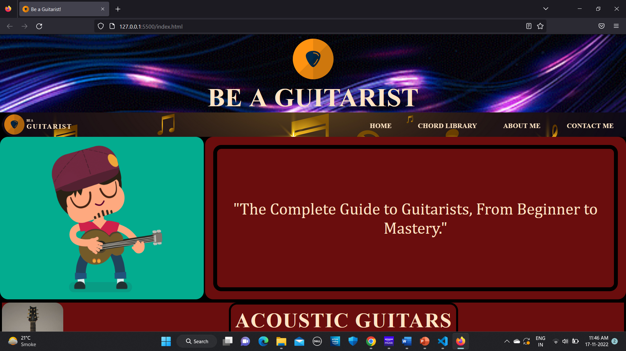

Fig 7.1 The website look like this.

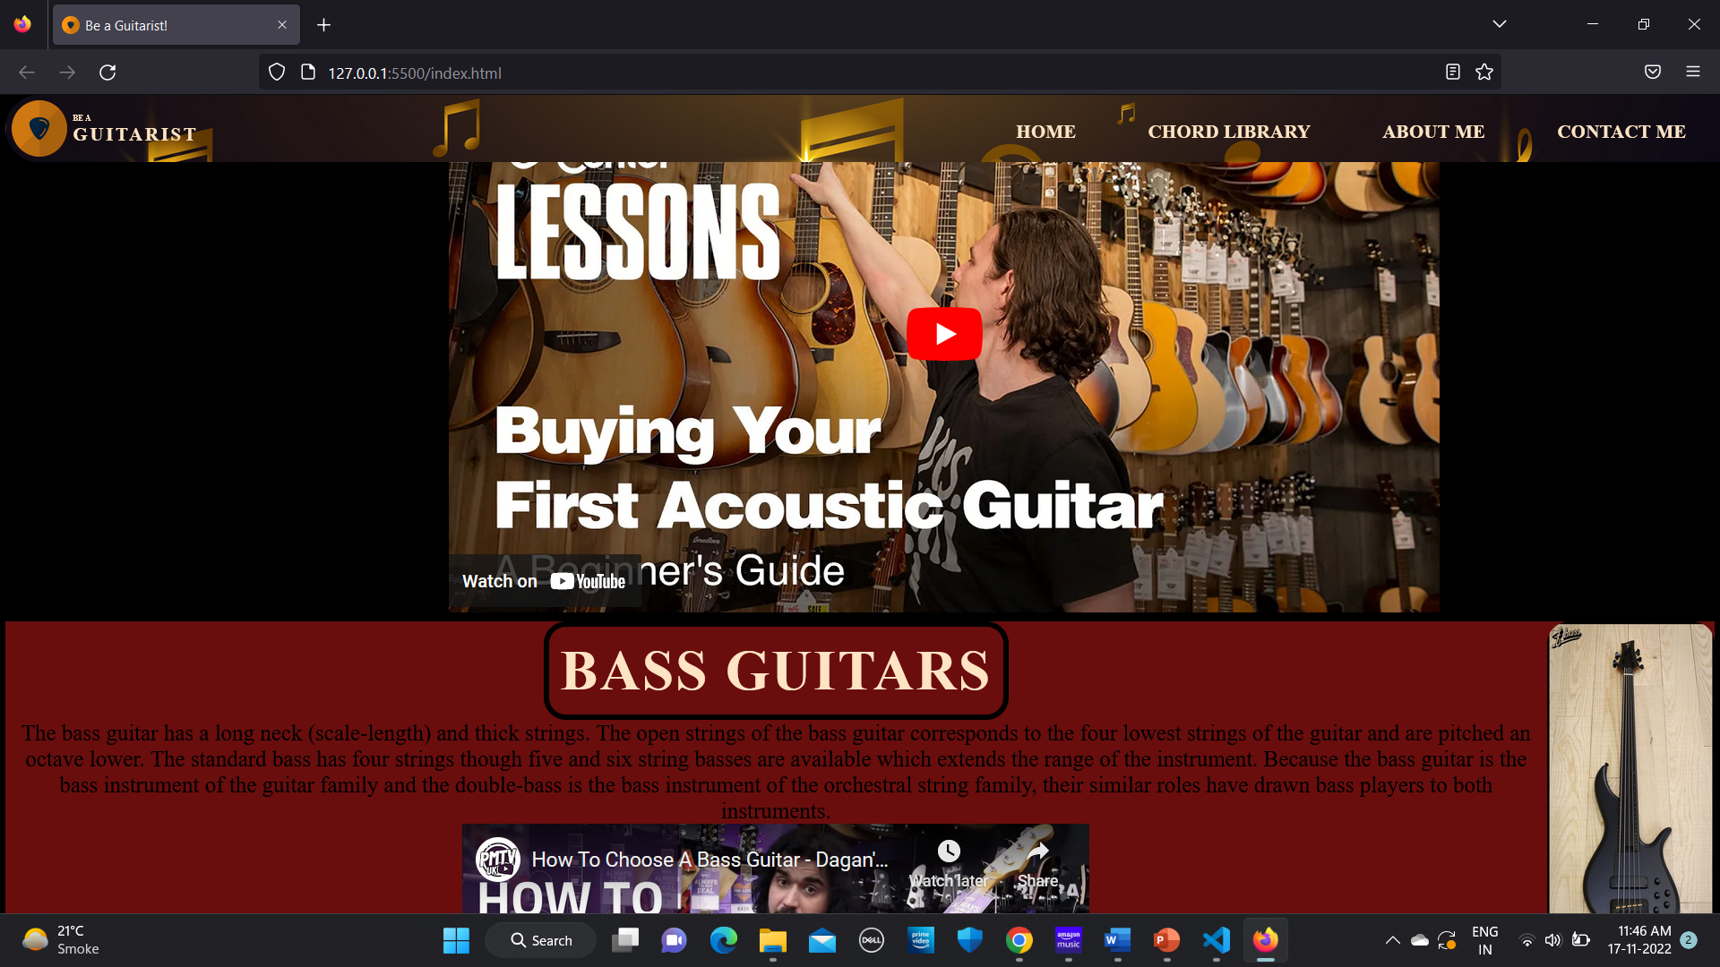

Fig 7.2 different links.

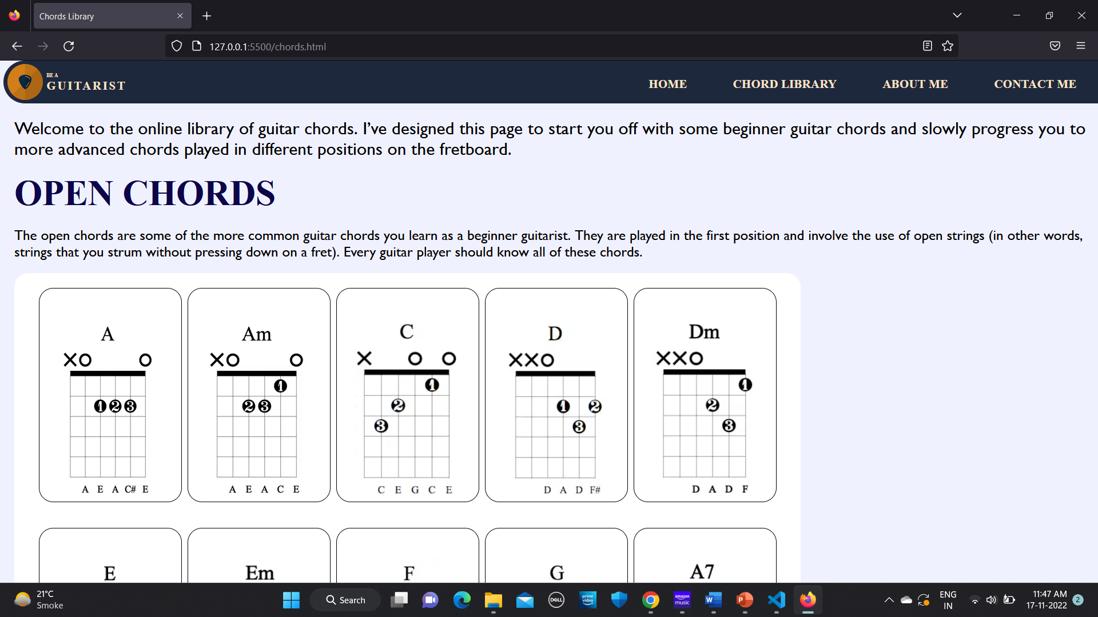

Fig 7.3 The Chord Library

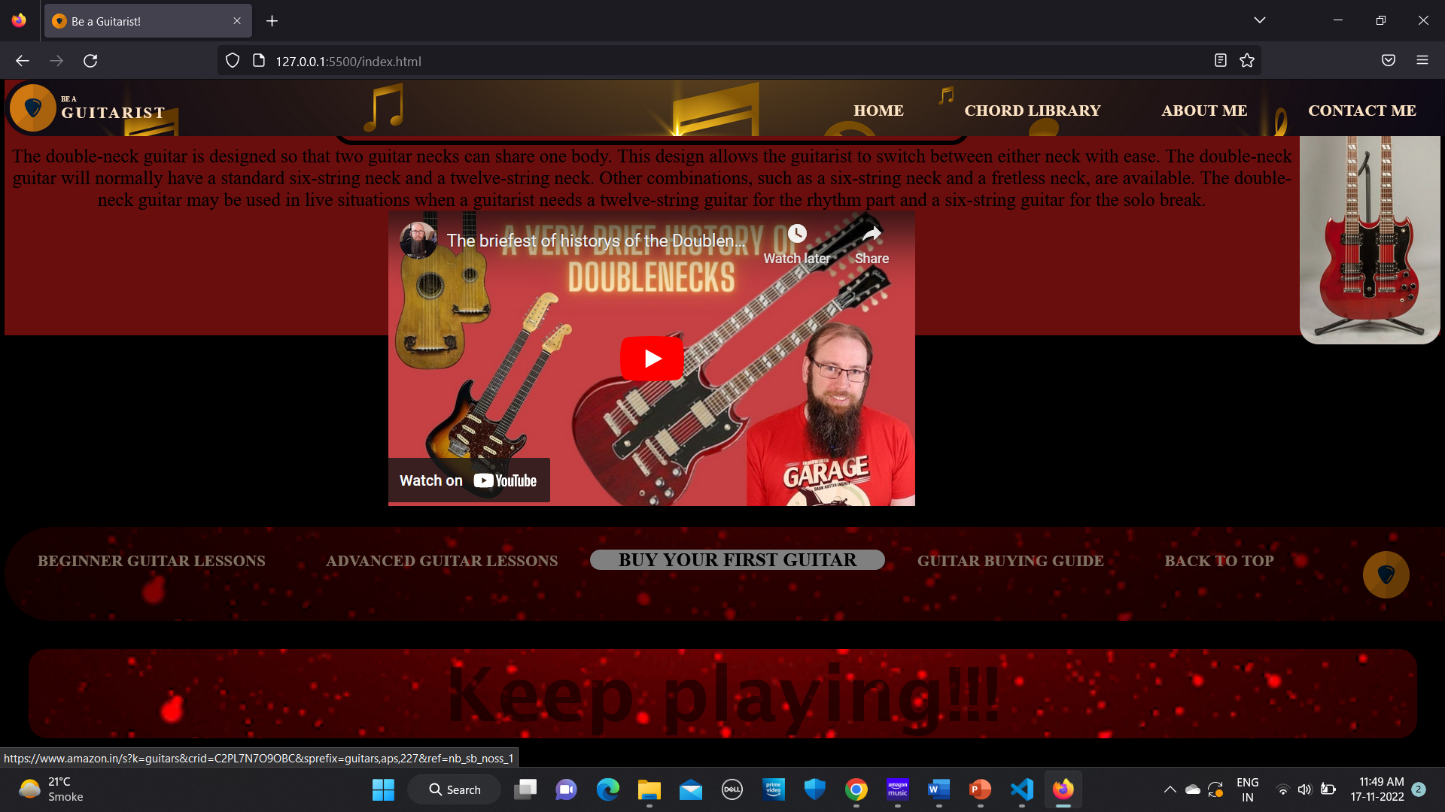

Fig 7.4 Links to videos and buying options

# CONCLUSION

It's challenging to learn something new every time. This website merely tries to make things simple by offering the necessary requirements of a novice and doing its best to satisfy them. By offering all the necessary links, resources, and libraries, the user won't feel the need to look elsewhere. The website's e-commerce connection can be used as a revenue-generating affiliate marketing tool. Lessons are also chosen to aid novices on their journey by bearing in mind their point of view. Every aspect on this website is created using HTML and CSS, with no additional complicated technicalities for beginners and a user-friendly interface.

# REFERENCES

* + 1. <https://web.dev/learn/css/>
    2. <https://www.w3schools.com/CSSref/sel_hover.php>
    3. <https://www.geeksforgeeks.org/design-a-web-page-using-html-and-css/>